William Holland
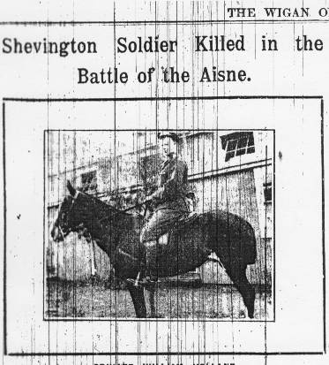
“Shevington Soldier Killed in the Battle of the Aisne” from the Wigan Observer, 17th October, 1914.
“Private William Holland, of Gathurst Lane, Shevington, was killed in action on 13th September in the Battle of the Aisne. The deceased soldier who was in the 2nd Lancashire Fusiliers mounted infantry fought at Mons and also on the Marne. For six years he was stationed in India. He leaves a widow and one child. All the members of the deceased’s family attended divine service at Shevington Church on Sunday last. The photograph which we publish above was taken at the Curragh Camp, Ireland.”
William is remembered on the memorial at La Ferte-Sous-Jouarre, which was erected for the men of the British Expeditionary Force which went to France at the outbreak of the First World War. La Ferte-Sous-Jouarre is a small town on the N3, forty miles east of Paris.
The memorial's English inscription says:
To the glory of God and the lasting memory of 3888 British officers and men whose graves are not known who landed in France in the month of August 1914 and between then and October fought at Mons and Le Cateau and on the Marne and the Aisne
William’s family
There is a slight question over the exact identification of William. This appears to fit with the known facts:-
According to the War Graves website William was the son of George and Esther Holland of the Prince Albert Inn, Goose Green, and husband of Mary Holland of 33 Gathurst Lane.
In 1891 George was a gamekeeper at Standish Hall, where he lived in the keeper’s cottage along with five children and Mary, 75-year-old mother-in-law, recorded as “living on own means”.
10 years later the family had moved to Back Lane. There were now 10 children, William being the fourth, two working at the Linoleum Works, and William being a coal miner’s drawer. Not surprisingly the eldest daughter, Annie, is shown as being “servant at home, domestic”. Father George was still a gamekeeper.
In 1911 the family had moved to Goulding’s Farm, Back Lane. Father was still a gamekeeper, and William is shown as an army reservist and underground labourer, coal mine.
This would fit with the article in the Wigan Reporter which said that William had been stationed in India for six years.
On 1st Jan 1913 William married Mary Robinson at St Anne's, Shevington. She was described as 34, a spinster, of Gathurst Lane, Shevington. Did she own the house at no. 33? They would have been less than two years married when William died.
- o – o – o – o – o -
A cross of remembrance was left at the War Memorial one year remembering a William Holland who died in 1916 at the age of 18. The War Graves Commission does not have a record which fits those facts.
William’s work
William had spent time in India as a professional soldier.
In peacetime a substantial number of British imperial troops were posted to India on garrison duty and to help secure the volatile North-West Frontier region bordering Afghanistan. Most of these units were recalled to England or sent to France after the outbreak of the war. Where possible, they were replaced by Territorial Army units sent out from the United Kingdom. Throughout the war the British government was careful not to make too great a demand on the Indian Army to contribute forces to operations overseas. The British continued to see the Indian Army’s primary role as protecting and maintaining the security of British India.
One wonders whether he was at the Delhi Durbar of 1911.

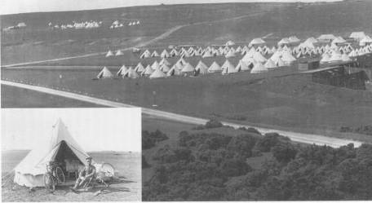
William did part of his training at the Curragh Camp. The Camp was a British military training camp until it was handed over to the Irish Army in 1922. It is on a large flat plain in County Kildare, in the Irish Republic, close to the Curragh Racecourse.
What happened to William?
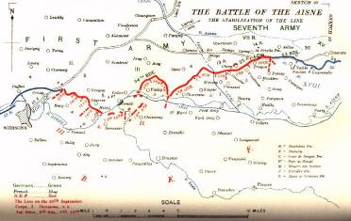
William, a member of the British Expeditionary Force, died at the Battle of the Aisne.
The First Battle of the Aisne was the Allied follow-up offensive against the right wing of the German First and Second Armies. The offensive began on the evening of 13th September, 1914, after a hasty pursuit of the Germans. When the Germans turned to face the pursuing Allies they held one of the most formidable positions on the Western Front, the north bank of the River Aisne.
In dense fog on the night of 13th September, most of the British Expeditionary Force crossed the Aisne on pontoons or partially demolished bridges. Under the thick cover of the foggy night, the BEF advanced up the narrow paths to the plateau. When the mist evaporated under a bright morning sun, they were mercilessly raked by fire from the flank. Those caught in the valley without the fog's protective shroud fared no better.
The battle also marked the beginning of trench warfare as Allied and German forces entrenched during and after the Battle of the Aisne in mid-September. By November battle lines had been drawn that would remain virtually unchanged for almost four years.
One soldier who died and whose body was never identified was William Holland of Gathurst Lane.

